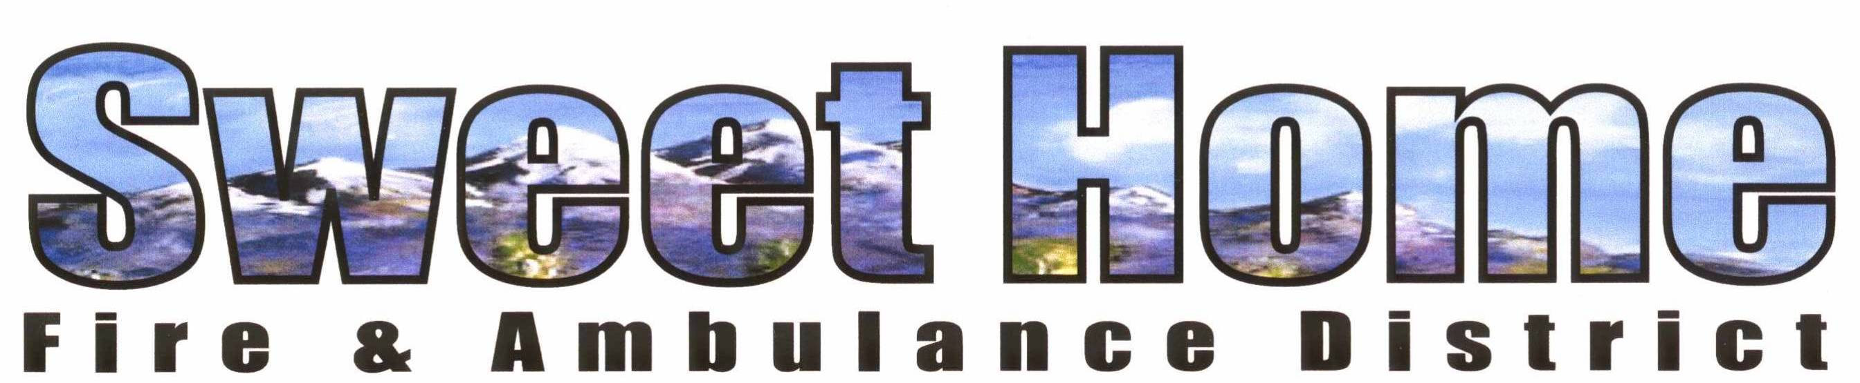

PUBLIC NOTICE

WHAT: SHFAD Special Board Meeting

WHEN: Wednesday October 23rd, 2024

TIME: 7:15 P.M.

WHERE: 1099 Long Street, Sweet Home

AGENDA: Adoption of resolution 2024-06, Acceptance of terms and conditions of property purchase using bond dollars; disclosing signers and capacity to sign for said purchase.

The public is always welcome to attend these meetings. You can also join this meeting via zoom. Zoom meeting weblink:
https://us06web.zoom.us/j/84020512336 ID# 840 2051 2336, admission by host required.

